|  |  |
| --- | --- |
| **YEAR 8** | **Gravitational Potential Energy** |

|  |  |
| --- | --- |
| **Learning Intentions** | **Success Criteria** |
| Understand gravitational potential energy (GPE). | * Define gravitational potential energy and provide examples. * Describe the concept of gravitational potential energy. * Explain how GPE changes with height and mass. * Calculate gravitational energy using:  GPE or Ep = weight x height = mass x gravity x height |

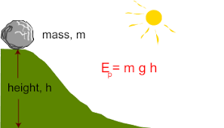

Image: <http://physics-schooluk.com/changes_in_energy.html>

**READ:** *Gravitational Potential Energy (GPE)*

The **Gravitational potential energy (GPE)** is the amount of energy an object has because of its position above the ground, i.e. its height. Gravitational potential energy can be shortened to **GPE** or **Ep** .

When a bungee jumper **falls**, he/she **loses GPE**. As the **elastic cord pulls** the bungee jumper back up, he **gains GPE**. If he were to forget his cord and **hit the floor**, he/she would have **zero GPE**.

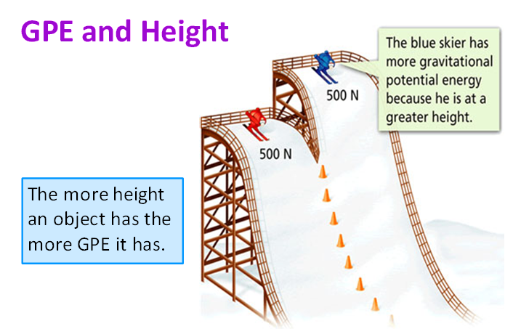 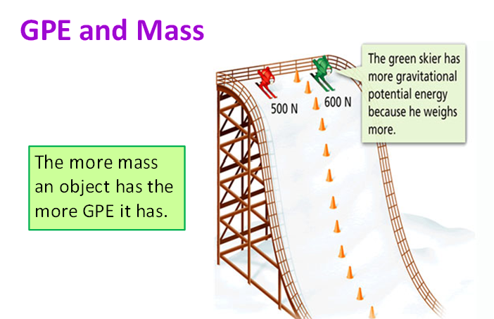

Images: <https://www.solarschools.net/knowledge-bank/energy/forms/potential>

**ACTIVITY 1:** *Energy Skate Park*

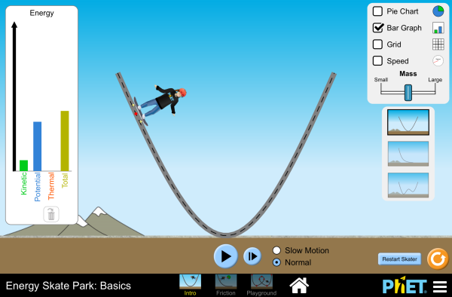

Image: <http://phet.colorado.edu/sims/html/energy-skate-park-basics/latest/energy-skate-park-basics_en.html>

**YOUR TASK:**

1. Go to the PhET “Energy Skate Park” and explore the interactive.  
   <http://phet.colorado.edu/sims/html/energy-skate-park-basics/latest/energy-skate-park-basics_en.html>
2. Complete the summary Quiz questions on the next page.

**ENERGY SKATE PARK**

|  |  |
| --- | --- |
| http://www.proprofs.com/quiz-school/upload/yuiupload/814128334.jpg  **Image:** <http://phet.colorado.edu/sims/html/energy-skate-park-basics/latest/energy-skate-park-basics_en.html> | 1. [**What type of energy does the skater possess when he is at the greatest height on the track as shown in the picture above?**](https://www.proprofs.com/discuss/q/237678/what-type-energy-does-skater-possess-when-greatest-height-tr)   A. Elastic potential energy only  B. Gravitational potential energy only  C. Kinetic energy  D. Gravitational potential energy and kinetic energy |
| http://www.proprofs.com/quiz-school/upload/yuiupload/523725237.jpg  **Image:** <http://phet.colorado.edu/sims/html/energy-skate-park-basics/latest/energy-skate-park-basics_en.html> | 1. **What type of energy does the skater possess when he is moving pass the bottom of the track as shown in the picture above?**   A. Elastic potential energy only  B. Gravitational potential energy only  C. Kinetic energy only  D. Gravitational potential energy and kinetic energy |
| http://www.proprofs.com/quiz-school/upload/yuiupload/1400945202.jpg  **Image:** <http://phet.colorado.edu/sims/html/energy-skate-park-basics/latest/energy-skate-park-basics_en.html> | 1. [**What type of energy does the skater possess as he is moving up the track as shown in the picture above?**](https://www.proprofs.com/discuss/q/419334/what-type-energy-does-the-skater-possess-moving-track-shown-)   A. Elastic potential energy only  B. Gravitational potential energy only  C. Kinetic energy only  D. Gravitational potential energy and kinetic energy |
| http://www.proprofs.com/quiz-school/upload/yuiupload/1391263160.jpg  **Image:** <http://phet.colorado.edu/sims/html/energy-skate-park-basics/latest/energy-skate-park-basics_en.html> | 1. **Which of the following statements regarding the skater is correct as he moves from position A to B?**   A. Skater possesses less gravitational potential energy at position A as compare to when he is at position B.  B. Skater possesses more energy at position A as compare to when he is at position B.  C. Skater possesses more gravitational potential energy at position A as compare to when he is at position B.  D. Skater possesses the same amount of gravitational potential energy at both positions A and B. |
| http://www.proprofs.com/quiz-school/upload/yuiupload/1391263160.jpg  **Image:** <http://phet.colorado.edu/sims/html/energy-skate-park-basics/latest/energy-skate-park-basics_en.html> | 1. **Which of the following statements regarding the skater is correct as he moves from location A to B?**   A. Skater possesses less kinetic energy at position A as compare to when he is at position B.  B. Skater possesses more energy at position A as compare to when he is at position B.  C. Skater possesses more kinetic energy at position A as compare to when he is at position B.  D. Skater possesses the same amount of kinetic energy at both positions A and B. |
| http://www.proprofs.com/quiz-school/upload/yuiupload/1255865325.jpg  **Image:** <http://phet.colorado.edu/sims/html/energy-skate-park-basics/latest/energy-skate-park-basics_en.html> | 1. **The pie chart below shows the energy of the skater at a particular position as he moves through the track. Which of the following positions is the skater at?**   A. Position A C. Position C  B. Position B D. Position D |
| http://www.proprofs.com/quiz-school/upload/yuiupload/126075483.jpg  **Image:** <http://phet.colorado.edu/sims/html/energy-skate-park-basics/latest/energy-skate-park-basics_en.html> | 1. **The picture above shows the skater at the starting point for his skate.  Which position in the picture indicates the greatest height the skater can reach.**   A. Position A  B. Position B  C. Position C  D. Position D |
| http://www.proprofs.com/quiz-school/upload/yuiupload/997116012.jpg  **Image:** <http://phet.colorado.edu/sims/html/energy-skate-park-basics/latest/energy-skate-park-basics_en.html>  http://www.proprofs.com/quiz-school/upload/yuiupload/1430154155.jpg  **Image:** <http://phet.colorado.edu/sims/html/energy-skate-park-basics/latest/energy-skate-park-basics_en.html> | 1. [**The skater moves from position A to D as shown in the picture below.   The four bar graphs below show the energy of the skater at the above four positions but in the wrong order. Which of the following shows the correct order of the energy of the skater as he moves from position A to D?**](https://www.proprofs.com/discuss/q/1062700/the-skater-moves-from-position-shown-picture-belowthe-four-b)   A. I, III, IV, II  B. II, III, I, IV  C. II, IV, I, III  D. II, IV, III, I  **ANSWERS:** B, C, D, C, A, C, C, C |

**READ:** *Calculating GPE*

Gravitational Potential Energy can be calculated using the formula:

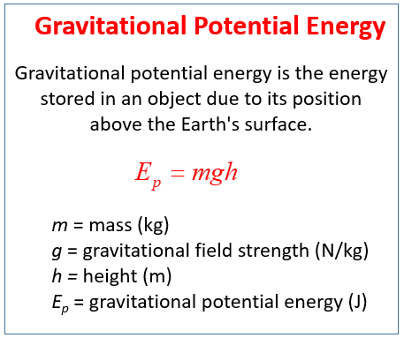

Source: <https://www.onlinemathlearning.com/gravitational-potential-energy.html>

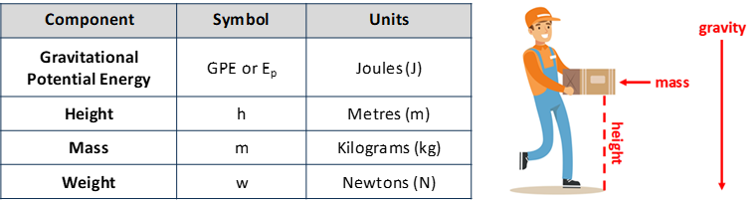

**To calculate GPE, follow these steps:**

1. What values do you know?
2. What value are you trying to find?
3. What equation should you use?
4. Put the values you know into your equation.
5. Solve the equation (you can use a calculator).
6. Give your final answer including units.

For example:

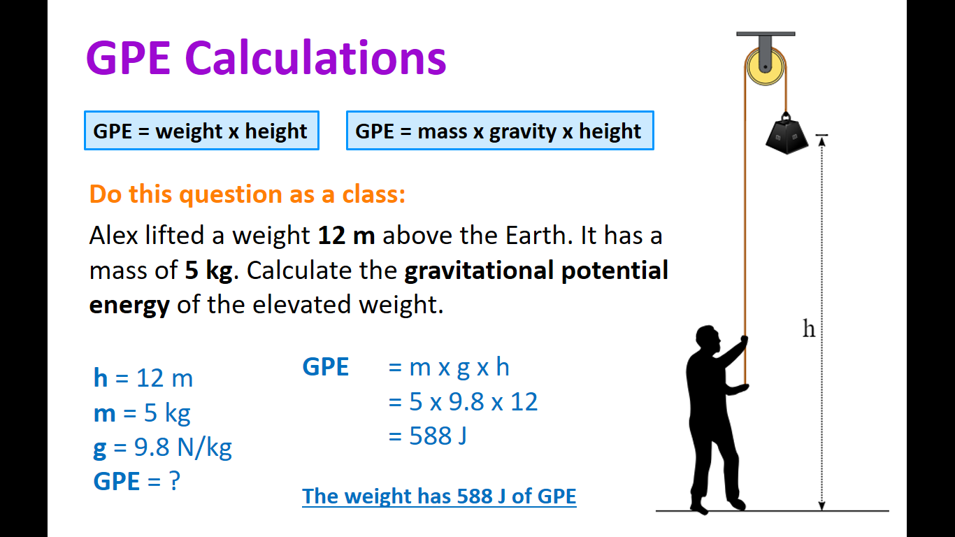

Image: <https://www.khanacademy.org/science/physics/work-and-energy/work-and-energy-tutorial/a/what-is-gravitational-potential-energy>

**ACTIVITY 2:** *Calculating GPE*

**YOUR TASK:** Use the formula’s provided to calculate GPE in the following situations.

1. Caden, who weighs 441 N, jumped from the 3 m diving board of a swimming pool. Calculate his GPE on the diving board.

|  |
| --- |
|  |

1. If Lotte lifts a mass of 7 kg onto a table 1.25 m high. How much GPE has the mass gained?

|  |
| --- |
|  |

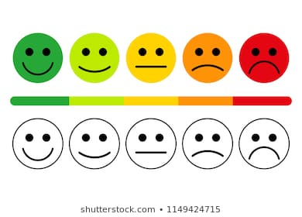

**[WARNING]**

Some of this material may have been copied [and communicated to you] in accordance with the statutory licence in section 113P of the Copyright Act. Any further reproduction or communication of this material by you may be the subject of copyright protection under the Act. Do not remove this notice.

These resources have been made available by the Department of Education Western Australia in response to COVID-19 on 22/04/2020 for your educational purposes. Do not distribute these resources for any other purpose.